KERALA PUBLIC SCHOOLS
ACADEMIC YEAR 2026-27
STD - IX - PORTION FOR MID TERM
SUBJECT | MID TERM WEEKLY TEST | MID TERM PERIODICAL TEST | MID TERM EXAMINATION
ENGLISH | Language – Letter to the Editor  Literature – How I Taught my Grandmother to Read  [Prose] | Language –  Writing Skills  1. Notice Writing  2. Letter to Editor  Grammar –  1.Tenses  2.Modals  Literature –  1.Bharat Our Land(poem)  2. The Pot Maker (prose) | Reading Skills  1. Descriptive /Discursive passage  [400 – 450 words]  2. Case Based passage  [200 -250 words]  Writing Skills  1. Formal Invitation  2. Notice Writing  3. Formal Email  4. Factual Description  5. Descriptive Essay  Grammar  1. Tenses  2. Modals  3. Reported Speech  4. Clauses – Nouns and Relative Clause  5. Subject Verb Concord.  Literature  1.The Pot Maker (prose)  2. Gifts Of Grace (poem)  3. Winds Of Change(prose  4. Canvas Of Soil (poem)  5. Vitamin M(prose)  6. I Cannot Remember My Mother (poem)
HINDI | 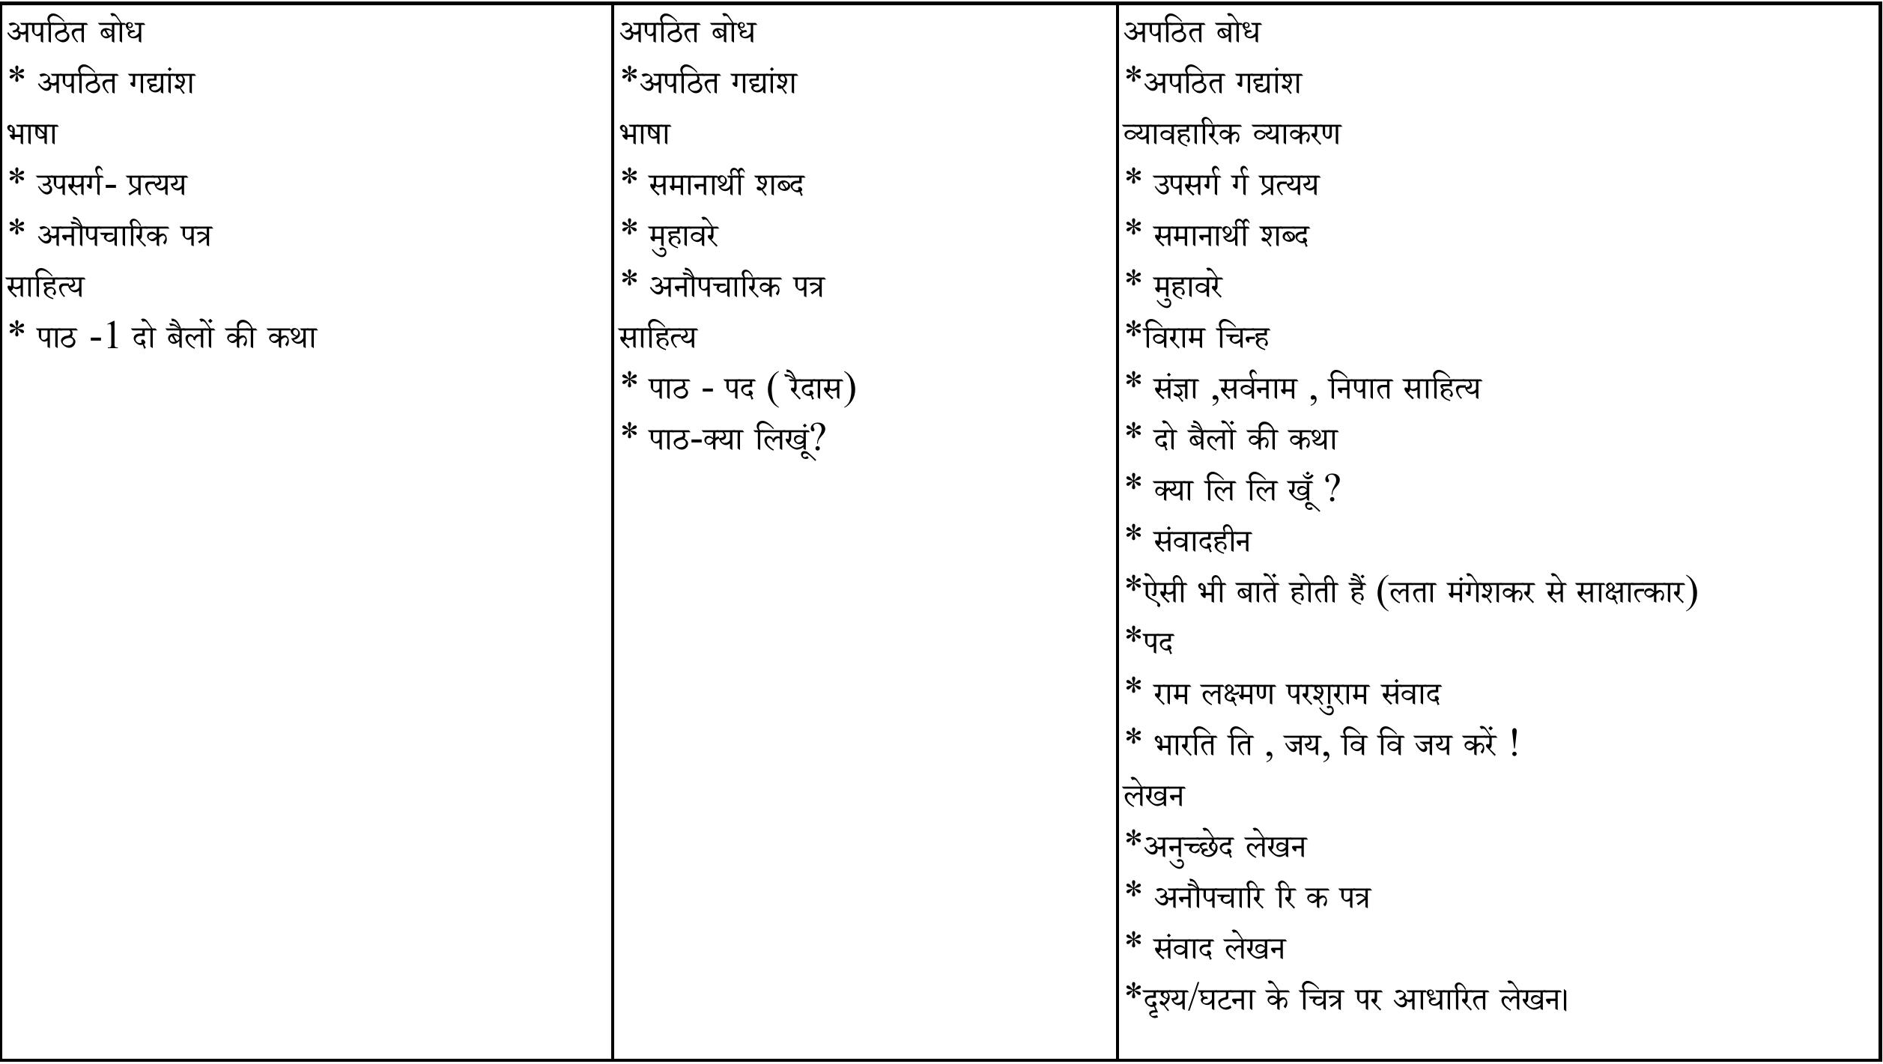
SANSKRIT |  |  | १. प्रथमः पाठः वयं वर्णमालां पठामः  २. द्वितीयः पाठः एषः कः ? एषा का ? एतत् किम् ?  ३. तृतीयः पाठः अहं च त्वं च  ४. चतुर्थः पाठः अहं प्रातः उत्तिष्ठामि  ५. पञ्चमः पाठः शूराः वयं धीराः वयम्  ६. षष्ठः पाठः सः एव महान् चित्रकारः  ७. सप्तमः पाठः अतिथिदेवो भव  खड़-क अपठित बोध - 10 अंक  खड़-ख व्याकरण पाठ्य पुस्तक आधारित - 15 अंक  सर्वनाम आधारित - 2 अंक  क्रिया आधारित। - 3 अंक  शब्दार्थ ( हिंदी / संस्कृत) - 3 अंक  शब्द रूप (बालक और लता) - 5 अंक  धातु रुप ( लट् लकार ) - 2 अंक  खंड -ग पाठ्य पुस्तक से अवबोधनात्मक प्रश्न - 20 अंक  प्रश्न उत्तर - 10 अंक  संस्कृत गद्यांश का हिंदी में अनुवाद - 10 अंक  खंड - घ रचनात्मक लेखन - 5 अंक  निम्नलिखित विषयों में से किसी एक पर पांच वाक्य संस्कृत में लिखें -  मम विद्यालय: , मम परिवार: , मम मित्रम , दैनिकचर्या
MATHEMATICS | Ch –3 The World of Numbers | Ch –3 The World of Numbers .  Ch – 2 Introduction to Linear Polynomials | Ch-1 Orienting Yourself – The use of Coordinates.  Ch -2 Introduction to Linear Polynomials  Ch –3 The World of Numbers  Ch – 4 Exploring Algebraic Identities  Ch- 5 I'm Up and Down. And Round and Round  Ch- 6 Measuring Space : Perimeter and Area  Ch -7 The Mathematics of May be: Introduction to Probability  Ch – 8 Predicting What Comes Next: Exploring Sequences and Progressions.
SCIENCE | PHYSICS:  Ch4 - Describing Motion around Us  Ch 6 - How forces affect the motion (Till 2nd law of motion)  CHEMISTRY:  Ch 5- Exploring mixture and their separation  Ch 8 - A Journey Inside the Atom (upto Rutherford's model of atom)  BIOLOGY :  Ch-2 Cell: The building block of Life  (till plasma membrane) | PHYSICS:  Ch4 - Describing Motion around Us  CHEMISTRY:  Ch 5- Exploring mixture and their separation  BIOLOGY :  Ch- 2. Cell: The building block of Life | Ch 5- Exploring mixture and their separation  Ch 8 A Journey Inside the Atom  Ch- 4 Describing motion around us  Ch-6 How forces affect the motion  Ch 1 Exploration: Entering the World of Secondary Science  Ch 2 - Cell: The building block of Life  Ch 3 - Tissues in Action
SOCIAL SCIENCE | Theme II-Shaping of the Earth's surface | Theme IV – Beginning of Civilisation | Theme I:-Understanding Social Science  Theme II:- Shaping of the Earth's Surface  Theme III :-Atmosphere and Climate  Theme IV:-Early Humans and Beginning of Civilisations  Theme V:-State and Society  Theme VI:- Democracy  Theme VII:-Elections  Theme VIII:-Building Blocks in Economics  Theme IX -The Price Puzzle: What Drives the Market
INFORMATION TECHNOLOGY |  | PART B  UNIT III (Digital Documentation)  (Chapter -3 to Chapter -8) | PART A : Unit I ,II,III  (Chapter -1 to Chapter – 8)  PART B : Unit I,II,III  (Chapter -1 to Chapter - 9)

